|  |  |  |  |  |
| --- | --- | --- | --- | --- |
| **TEST** | **EXPECTED** | **ACTUAL** | **P/F** | **NOTES** |
| Home page |  |  |  |  |
| User clicks on one of the menu pages (eg projects - photography) | Redirects to photography page | Redirects to photography page | pass | In the future maybe I could add a projects page instead of a dropdown menubut I think the dropdown is easier to navigate. |
| Click on contact me page | Redirects to contact me page | Redirects to contact me page | pass |  |
| Click on about me page | Redirects to about me page | Redirects to about me page | pass |  |
| View Illustration Gallery | Illustration gallary loads | Illustration gallary loads | pass |  |
| View photography Gallery | Photogrpahy gallary loads | Iphotography gallary loads | pass |  |
| View design work Gallery | Design work gallary loads | Design work gallary loads | pass |  |
| Project page |  |  |  |  |
| User clicks “view” button | Redirects to the individual article page | Redirects to the individual article page | pass | In the future I could add a hover element to the cards so that they look more professional. |
| About me page |  |  |  |  |
| User clicks “About Me” in navigation | Page content is loaded | Page content is loaded | pass | I can add more interactive elements in the about me page for a more interesting elements. |
| Contact me |  |  |  |  |
| Submit Contact Form | Validates input, sends message to backend/email | Validates input, sends message to backend/email | pass | For a more professional apearance, I could add a confirmation messege that is sent to the email provided to confirm that the contact had been made |
| User submits form with missing or incorrect info | Error message prompting corrections | Error message prompting corrections | pass |  |
| Other actions |  |  |  |  |
| User views site on different devices/screen sizes | System adjusts layout using CSS media queries | System adjusts layout using CSS media queries | pass | For the furture I can make the heading resize along with the page itself |

**Using validator to fix any errors:**

**Since I copy and pasted most of the basic code for the navbar or the footer or a list therre is a lot of repeated errors which are stray list elements and div elements that I accidentally added. Along with some unclosed elements.**

Along that I also had a couple of names for some of the images tht had “illegal” characters like spaces and periods that I changed.

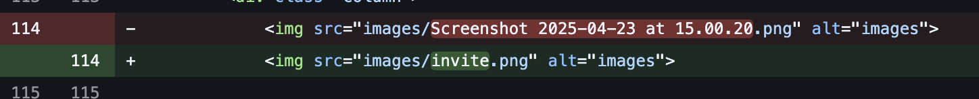

That was basically all the issues that where found, I went though each page and fixed all these issues, they where all the same issue but with a different page and the same issue with the names but with different one so I wont add all the differrent names that I changed as there were a lot and they are all the same issue.

Improvement notes:

I can work on making the gallery more interactive and maybe add some descriptions to each of the items that are shown on the gallery to be more informative.

I can add some accessibility features such as dark mode or some colour adjustment settings